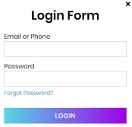

JWT Tokens  
for Authentication

CDMQ

Loan DB

View  
Templates

Components

LDAP

Service

Angular

HTTP  
Client

Spring Boot

Spring JPA

Spring Rest Controller